CASE STUDY
Telecom Customer Analytics, Fraud Detection & Network Optimization Platform

1. Problem Statement
A telecom company wants to build a modern data platform to:
- Monitor customer usage (calls, data, SMS)
- Detect fraudulent activities (SIM cloning, unusual usage)
- Optimize network performance
- Provide real-time dashboards
- Ensure data security, compliance, and cost efficiency

2. Business Goals
- Reduce fraud losses by 30%
- Improve network uptime to 99.9%
- Enable near real-time analytics
- Secure sensitive customer data (PII)
- Optimize storage & compute cost

3. Dataset Design (Core of Case Study)
3.1 Customer Table
Column | Type | Description
customer_id | INT | Unique ID
name | STRING | Customer name
phone_number | STRING | Sensitive (PII)
email | STRING | Sensitive
address | STRING | Sensitive
plan_type | STRING | Prepaid/Postpaid
activation_date | DATE | Activation

3.2 Call Detail Records (CDR)
Column | Type
call_id | STRING
customer_id | INT
call_start | TIMESTAMP
call_end | TIMESTAMP
call_type | STRING (Local/STD/ISD)
duration_sec | INT
tower_id | STRING

3.3 Data Usage
Column | Type
usage_id | STRING
customer_id | INT
usage_time | TIMESTAMP
data_mb | FLOAT
app_type | STRING

3.4 Network Tower Logs
Column | Type
tower_id | STRING
location | STRING
signal_strength | FLOAT
outage_flag | BOOLEAN
timestamp | TIMESTAMP

3.5 Fraud Events
Column | Type
fraud_id | STRING
customer_id | INT
event_time | TIMESTAMP
fraud_type | STRING
risk_score | FLOAT

4. Architecture Overview

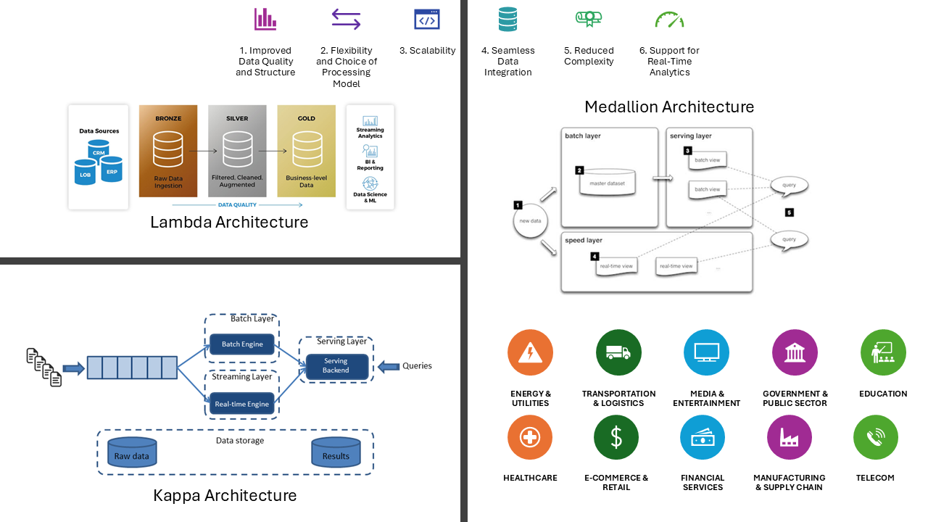
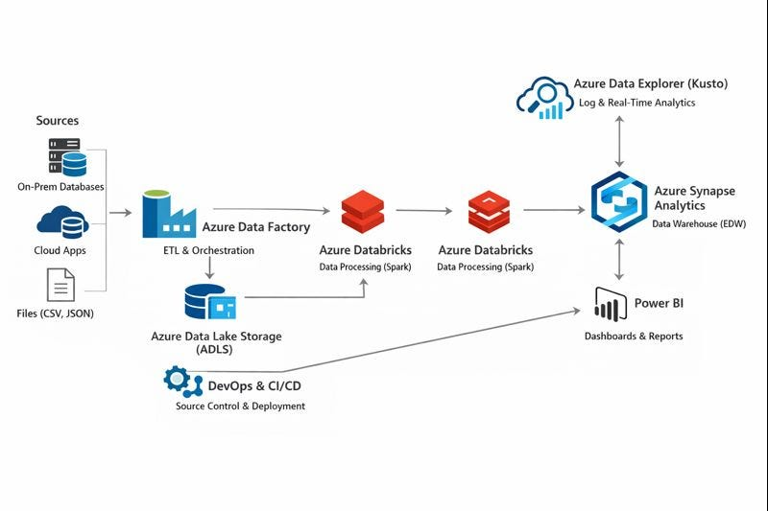
Flow
- Ingestion
  - Batch → Azure Data Factory
  - Streaming → Event Hub (CDR, usage)
- Storage
  - ADLS Gen2 (Bronze/Silver/Gold)
- Processing
  - Azure Databricks (Delta Lake)
- Serving
  - Synapse / Microsoft Fabric
- Visualization
  - Power BI

5. Module 10 — Security & Observability (Applied)

5.1 Encryption Strategy
At Rest
- ADLS → AES-256
- SQL → TDE
In Transit
- HTTPS for all pipelines

5.2 Sensitive Data Protection
Sensitive fields:
- phone_number
- email
- address
Data Masking Example
- phone_number → XXXX1234

5.3 Azure Key Vault Usage
Store:
- DB credentials
- API keys (fraud detection service)

5.4 Network Isolation
- Private Endpoint for:
  - ADLS
  - Databricks
- No public access

5.5 SQL Auditing
Track:
- Who accessed customer data
- Fraud queries

5.6 Observability
Using:
- Azure Monitor
- Log Analytics
Example Use Case
- Detect pipeline failures
- Monitor fraud spike

6. Module 11 — Optimization & Lifecycle

6.1 Storage Lifecycle
Data | Tier
Recent usage | Hot
3–6 months | Cool
>1 year | Archive

6.2 Delta Optimization
OPTIMIZE telecom_usage ZORDER BY (customer_id)
Why?
- Faster fraud detection queries

6.3 Partition Strategy
- Partition by:
  - date
  - region

6.4 Cost Optimization
- Auto-scaling clusters
- Spot instances for batch jobs

7. Module 12 — Architecture Decision Framework

7.1 ADF vs Databricks
Task | Tool
Ingestion | ADF
Transformation | Databricks

7.2 Synapse vs Databricks
- Fraud ML → Databricks
- BI dashboards → Synapse/Fabric

7.3 Fabric vs Synapse
- Fabric → Unified analytics
- Synapse → Advanced control

7.4 Serverless vs Dedicated
- Fraud queries → Dedicated
- Ad-hoc analysis → Serverless

7.5 Final Architecture Pattern
- Medallion Architecture
  - Bronze → Raw CDR
  - Silver → Cleaned
  - Gold → Aggregated KPIs

8. Module 13 — Microsoft Fabric Implementation

8.1 OneLake
- Central storage for telecom data

8.2 Lakehouse
- Store:
  - Customer
  - Usage
  - Fraud tables

8.3 Pipelines
- Data ingestion pipelines inside Fabric

8.4 DirectLake
- Power BI directly queries Lakehouse

8.5 End-to-End Flow
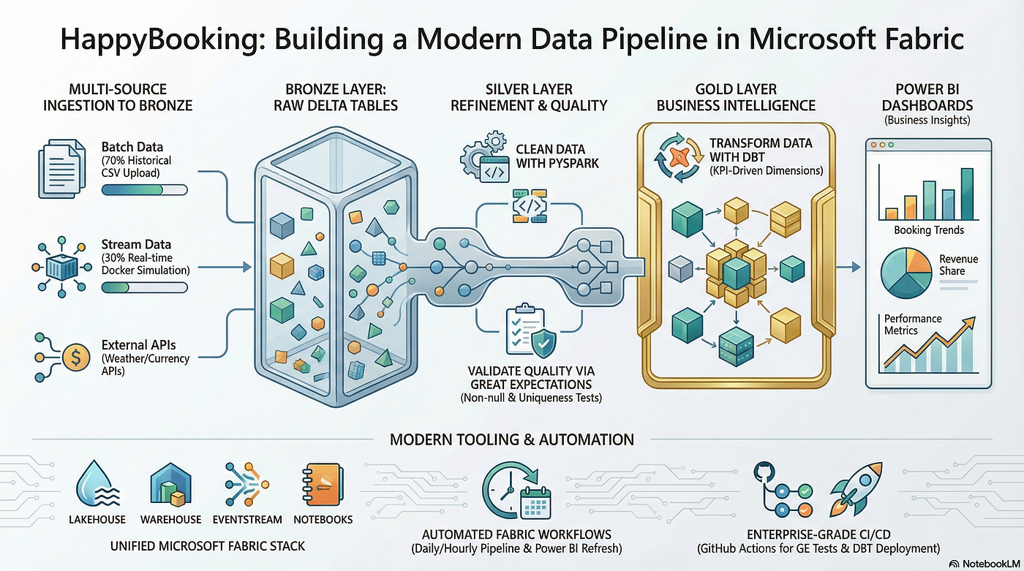
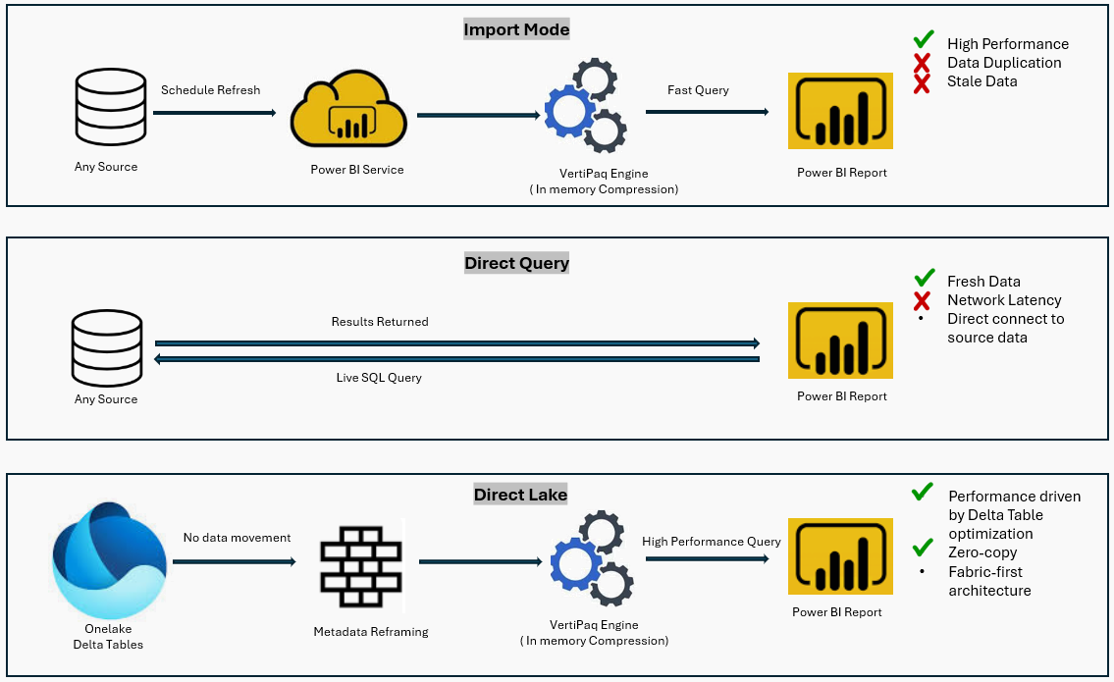
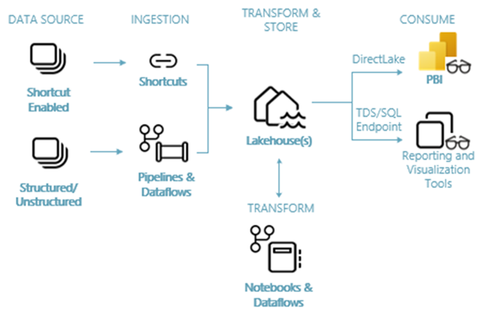

9. Sample Data Generation (Python)
Use this to simulate telecom dataset:
import pandas as pd
import random
from faker import Faker
fake = Faker()
customers = []
for i in range(1000):
customers.append({
"customer_id": i,
"name": fake.name(),
"phone_number": fake.phone_number(),
"email": fake.email(),
"address": fake.address(),
"plan_type": random.choice(["Prepaid", "Postpaid"]),
"activation_date": fake.date_this_decade()
})
df_customers = pd.DataFrame(customers)
df_customers.to_csv("customers.csv", index=False)

Generate CDR Data
cdr = []
for i in range(5000):
cdr.append({
"call_id": f"C{i}",
"customer_id": random.randint(0,999),
"call_start": fake.date_time_this_year(),
"call_end": fake.date_time_this_year(),
"call_type": random.choice(["Local","STD","ISD"]),
"duration_sec": random.randint(10,1000),
"tower_id": f"T{random.randint(1,50)}"
})
pd.DataFrame(cdr).to_csv("cdr.csv", index=False)

10. Real Use Cases

Fraud Detection
- Detect:
  - Sudden spike in ISD calls
  - Multiple locations → SIM cloning

Network Optimization
- Identify:
  - Towers with low signal
  - Frequent outages

Customer Analytics
- High data users
- Churn prediction

11. Expected Deliverables
- Data pipeline (ADF + Databricks)
- Secure architecture (Key Vault, Private Endpoints)
- Optimized Delta tables
- Fabric Lakehouse setup
- Power BI dashboard

